project management Plan

for

Car Purchasing App

V 1.0

VERSION HISTORY

|  |  |  |  |  |  |
| --- | --- | --- | --- | --- | --- |
| **Version** | **Implemented By** | **Revision Date** | **Approved By** | **Approval Date** | **Reason** |
| **1.0** | **Beshoy Sameh**  **Aml Mostafa** | **20/02/2023** | **Menna abdelmjeed**  **Salma gamal** | **21/02/2023** | **Initial Version** |
|  |  |  |  |  |  |
|  |  |  |  |  |  |
|  |  |  |  |  |  |
|  |  |  |  |  |  |
|  |  |  |  |  |  |
|  |  |  |  |  |  |
|  |  |  |  |  |  |

Contents

1. Introduction 4

1.1 Purpose of project management plan 4

1.2 Summary of project charter 4

I. Introduction 4

II. Company’s role and strength. 4

III. Business need 4

IV. Unique Solution 4

V. Timeline 4

VI. Team 4

1.3 Assumptions and Constraints 5

I. Assumptions: 5

II. Constraints: 5

1.4 Scope Management 5

1.5 Work Breakdown Structure 6

I. Diagram 6

3. Schedule / Time Management 7

3.1 Milestones 7

3.2 Project Schedule 7

3.3 Dependencies 8

5. Configuration Management 9

6. Communication Management 9

I. Communication goals: 9

II. Stockholders' communication: 9

III. Project Teams' communication: 10

7. Risk Management 11

9. Naming Convention for the Project 12

# Introduction

## Purpose of project management plan

The intended audience of the Car Purchasing PMP is all project stakeholders including the project sponsor, senior leadership, and the project team.

## Summary of project charter

### Introduction

**Our vision:** Be Number One choice for our Customer in Car Purchasing.

**Our mission:** Make Car Purchasing Easier for everyone everywhere.

### Company’s role and strength.

**Roles:** Project Manager, Business Analyst, Developers, Testers.

**Strength:** Cooperate, Flexible, Self-motivated, Cross-Functional and team-oriented

### Business need

Provides the easiest way to Car Purchasing, the fastest response.

### Unique Solution

Our website tries to be different as the customer finds a user-friendly interface with the highest performance possible to satisfy the customer.

### Timeline

We plan to provide Five milestones for the project and define the project as ready for publishing within 6 weeks of working as it needs approximately 212.5 hours.

(5 Engineers each work daily for 2 hours 85% Capacity)

### Team

Our team consists of 5 members as follow:

1. Aml Mostafa
2. Beshoy Sameh
3. Menna Abdelmjeed
4. Salam Gamal
5. Ahmed Fouda

## **Assumptions and Constraints**

### Assumptions:

* Search engine includes searching by Car brand and price.
* A button for adding cars is added to enable sellers to market and submit info about the cars they want to sell.
* Admin can approve and decline car addition, deletion and reservation.

### Constraints:

* Should use Web based System.
* Should obtain Unique user IDs

## **Scope Management**

### In Scope:

* The scope of this project includes design, implementation and testing of the features described in the succeeding sections of this document.
* Acceptance testing .
* Functional testing & external interfaces .

### Out of Scope:

* Non-functional testing like stress, performance
* Unit and automation testing
* Integration testing
* Payment method

## Work Breakdown Structure

## Diagram

# Schedule / Time Management

## Milestones

| **Milestones** | **Estimated Completion Timeframe** |
| --- | --- |
| - Sample in Question (SIQ)  - Software Requirements Specification (SRS)  -Project Management Plan (PMP)  -Configuration Management Tool setup  -Project Schedule | * Release One * One Week |

## Project Schedule

## Dependencies

We are following the Waterfall Model of SDLC

(But we are also using some Agile methodologies in reviewing and daily meetings)

Each step depends on the previous step (Finish to Start)

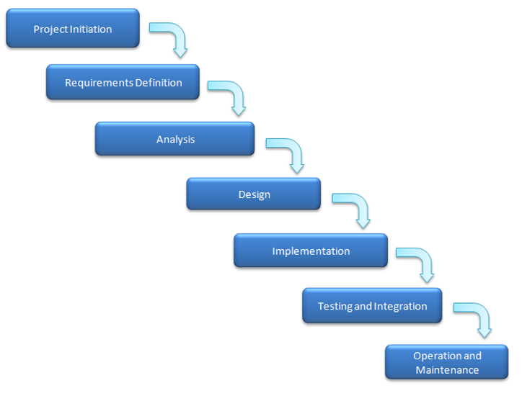

# Configuration Management

We tailored our Configuration Management tool to use GitHub

The guidelines on how we will use the CM:

|  |  |
| --- | --- |
|  |  |

* Pull requests are required for the master branch only.

* Folder Structure:

Readme File is provided to help identifying the location of each file in the below Link:

<https://github.com/beshoysamehsamaan/Car-Purchasing-App>

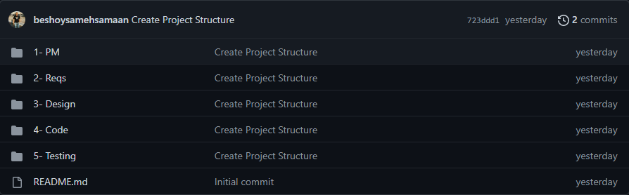

# Communication Management

Communication plan

### Communication goals:

-keep the stakeholder informed with all new updates and all the project needs

-Provide clear insight into any decisions needed or roadblocks

-Provide structured opportunities for feedback from stockholders

### Stockholders' communication:

-We are going to use formal mails to communicate and clarify some points in addition to the meetings whether it's an online or offline so as to take their feedback on the work and if they want to introduce any changes or suggestions

### Project Teams' communication:

-We are going to use formal mails to communicate and clarify some points in addition to the meetings whether it's an online or Face-to-face so as that we can discuss all what we have and take each other opinions

-Also, we can use some social media apps as what's app or Trello for easier and faster communication

# Risk Management

External Risk Management File in the below Link:

# **Naming Convention for Car Purchasing Project**

* Project Name for short will be (C)
* Space Separation between words by (‘_’)
* In Files Naming

- Must Capitalize First Char

- Acronym Must Be Uppercase

* When using Excel sheet Must stick to the previous rule with meaningful naming